By Portia Mdun

Be the champion of the galaxy needs…..
SPACE - BLASTERS
User Manual

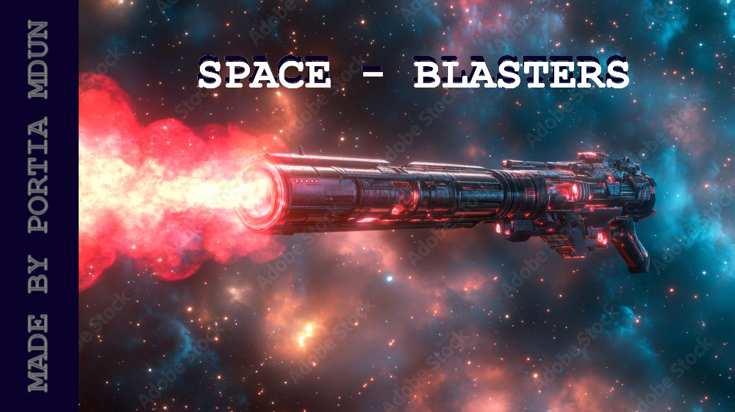

🚀 Space Blasters: Galactic Defense Protocol – User Manual
By Portia Mdun
🪐 Welcome, Commander
Space Blasters is an immersive 2D space shooter developed with vanilla WebGL and powered by JavaScript and glMatrix for dynamic transformations, fluid projections, and real-time texture rendering.
In this interstellar campaign, you assume the role of Earth's last hope—a heroic ace pilot tasked with neutralizing an onslaught of hostile alien entities and destructive celestial debris before they obliterate the planet. Victory requires not only rapid reflexes but strategic weapon deployment and situational awareness across an ever-hostile cosmos.

🎮 Game Objective

The ultimate mission is to:
- Intercept and eliminate enemy threats before they breach Earth’s atmospheric defenses.
- Survive waves of enemy encounters using your ship’s directional and firing systems.
- Earn points for each successful kill.
- Summon and defeat the Boss to become the undisputed Guardian of Earth.

⚙️ Game Mechanics & Controls

Controls
- Move Up: ↑ Arrow Key
- Move Down: ↓ Arrow Key
- Move Left: ← Arrow Key
- Move Right: → Arrow Key
- Shoot: Spacebar
  - Long Press: Activates Rapid Fire mode for continuous bursts.
  - Short Press: Enables Tactical Fire mode for controlled periodic shots.
- Start Game: Press R
- Pause Game: Press P
- Resume Game: Press P again

The Player

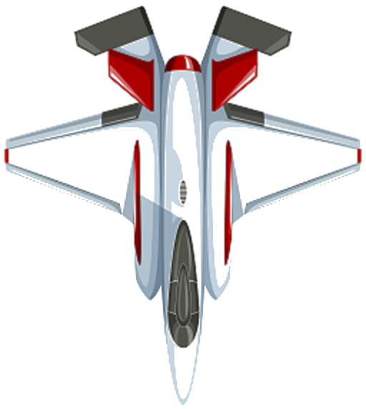
🧍 The Pilot (Player)
You, the Commander, navigate in 2D space using your ship's propulsion system, controlled via the arrow keys. The ship is equipped with an energy-based pulse cannon (activated with the spacebar). You have 3 lives—each collision with an enemy reduces your durability. Flashing red indicates damage; three hits result in mission failure.

The Bullets

🔫 Weapons System
- Energy Pulse Bullets are your primary ammunition.
  - Travel at a fixed speed.
  - Fire rate varies by input (long or short space bar presses).
- Ammunition does not deplete—strategic use of firing modes is key.

Enemies
👾 Hostile Entities



Meteorites
- Rocky celestial bodies.
- Require 5 direct hits to destroy.
- Highly damaging on contact.

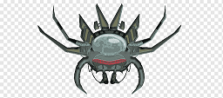
Flying Pawns
- Fast-moving alien drones.
- Easily eliminated with 1 hit.
- Appear frequently but are deadly if ignored.
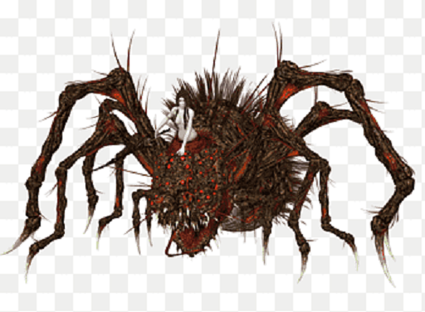

Invincibles
- Large, heavily armored enemies.
- Require 10 hits to destroy.
- Upon destruction, spawn 2 Flying Pawns.
- Eliminating 10 Invincibles summons the final boss.



☠️ Final Encounter – The Evil Skull (Boss)
- An advanced enemy AI unit.
- Highly agile, random movement patterns.
- Equipped with evasive maneuvers and devastating attacks.
- Requires 20 precise shots to eliminate.
- Defeating the boss signifies ultimate mastery of the battlefield.

Playability
The objective of the game is to hit as many as possible enemies, with every enemy struck, the player receives points, which will be displayed on the top left side of the screen.
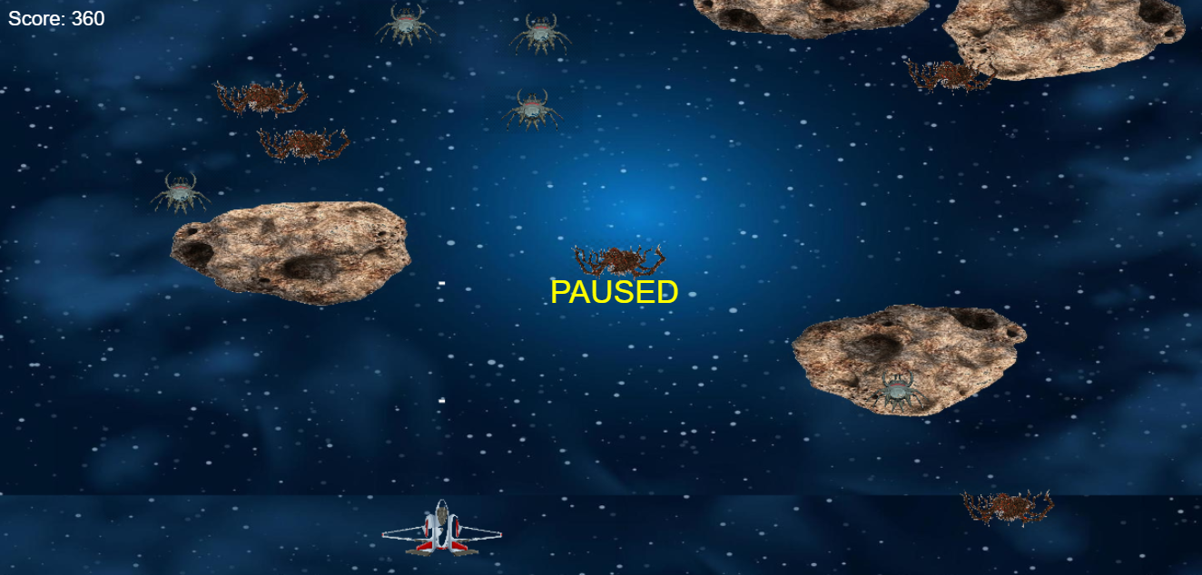
🏆 Scoring System
- Meteorite Destroyed: +10 points
- Flying Pawn Destroyed: +5 points
- Invincible Destroyed: +20 points
- Boss Destroyed: +100 points
Your total score is displayed on the top-left of the screen in real time.

💡 Tactical Tips
- Use Rapid Fire against tanker foes like Invincibles and the Boss.
- Utilize Tactical Fire to conserve screen space and manage bullet flow.
- Movement is survival—never stay static.
- Plan your shots—wasted fire might cost precious seconds in boss battles.

🎯 Mission Summary
Become Earth's intergalactic savior by mastering flight dynamics, weapon precision, and survival instincts. Engage in tactical space combat, obliterate alien forces, and reclaim the skies.

